
SVKM’s INSTITUTE OF TECHNOLOGY, DHULE
Department of Information Technology
Academic Year 2025-26

Experiment 3

Name: Bhupesh Anil Suryawanshi
Roll No.: 63
Batch: B3

Aim: Implement Backpropagation Algorithm

Theory:

What is Backpropagation?

Backpropagation (short for "backward propagation of errors") is a supervised learning algorithm used to train artificial neural networks. It updates the weights and biases of the network to minimize the prediction error using gradient descent and the chain rule of calculus.
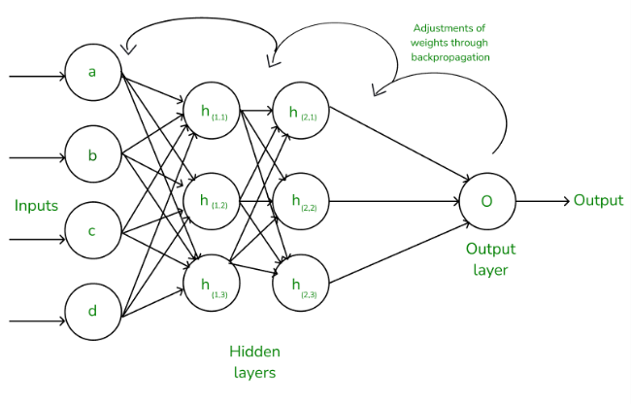
Why is Backpropagation Important?

In a neural network, the performance depends on correctly tuning the weights. Backpropagation provides an efficient way to compute the gradient of the loss function with respect to all the weights in the network, allowing the model to learn from data.

Working of Backpropagation

1. Forward Pass:

Input data is passed through the network.
Each neuron computes a weighted sum and applies an activation function (e.g., Sigmoid, ReLU).
The final output is produced.

2. Loss Calculation:

The error between the predicted output and the actual target is computed using a loss function, such as:
Mean Squared Error (MSE) for regression
Cross-Entropy Loss for classification

3. Backward Pass:

The error is propagated backwards through the network.
Gradients of the loss with respect to each weight are computed using the chain rule.

4. Weight Update:

Weights and biases are updated using Gradient Descent:
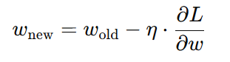
where η is the learning rate and $\frac{∂L}{∂ω}$ is the gradient of the loss.

Repeat:

Steps 1 to 4 are repeated for multiple epochs until the loss converges.

Activation Functions:

Sigmoid:
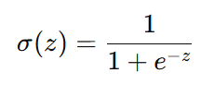
Tanh: ​
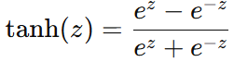
ReLU:
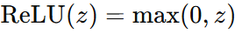

Loss Functions:
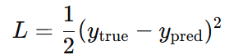
Mean Squared Error (MSE):
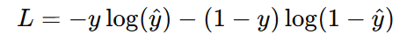
Cross-Entropy (for classification):

Optimization Techniques:

Stochastic Gradient Descent (SGD)
Mini-batch Gradient Descent
Adam Optimizer

Advantages of Backpropagation:

Simple and efficient to implement
Works for deep and complex networks
Scales well with large datasets
Supports various architectures (CNNs, RNNs, etc.)

Program:

import numpy as np

class NeuralNetwork:
def __init__(self, layers, alpha=0.1):
# layer: list of integers representing the number of nodes in each layer
# alpha learning rate
self.w=[]
self.layers = layers
self.alpha = alpha

# Initialize weights with small random values
for i in np.arange(0,len(layers)-2):
w=np.random.randn(layers[i]+1, layers[i+1]+1)
self.w.append(w/np.sqrt(layers[i]))
# Special case for output layer (no bias unit)
w=np.random.randn(layers[-2]+1,layers[-1])
self.w.append(w/np.sqrt(layers[-2]))

def sigmoid(self, x):
return 1.0 / (1 + np.exp(-x))

def sigmoid_deriv(self, x):
return x * (1 - x)

def fit(self, x, y, epochs=1000):
X = np.c_[x, np.ones((x.shape[0], 1))] # Add bias to input

for epoch in range(epochs):
for i in range(x.shape[0]):
A = [X[i]] # Store activations for each layer

# Forward propagation
for layer in np.arange(0, len(self.w)):
net = A[layer].dot(self.w[layer])
output = self.sigmoid(net)
A.append(output)

# Backpropagation
error = A[-1] - y[i] # Error at output layer
D = [error * self.sigmoid_deriv(A[-1])] # Delta for output layer

# Propagate errors backward
for layer in np.arange(len(self.w) -1, 0, -1):
delta = D[-1].dot(self.w[layer].T) * self.sigmoid_deriv(A[layer])
D.append(delta)
D = D[::-1] # Reverse deltas to match layer order

# Update weights
for layer in np.arange(0, len(self.w)):
self.w[layer] += -self.alpha * A[layer].reshape(-1, 1).dot(D[layer][np.newaxis, :])

def predict(self, X):
p = np.c_[X, np.ones((X.shape[0], 1))] # Add bias to input
for layer in np.arange(0, len(self.w)):
p = self.sigmoid(p.dot(self.w[layer]))
return p

# Create XOR dataset
X = np.array([[0, 0], [0, 1], [1, 0], [1, 1]])
y = np.array([[0], [1], [1], [0]])

# Initialize and train the network
nn = NeuralNetwork([2, 2, 1], alpha=0.5) # 2 input, 2 hiden, 1 output
nn.fit(X, y, epochs=20000)

# Make predictions and evaluate
predictions = nn.predict(X)
print("Predictions after training:")
print(predictions)

# Threshold predictions for binary classification
binary_predictions = (predictions > 0.5).astype(int)
print("\nBinary Predictions:")
print(binary_predictions)

# Calculate accuracy
accuracy = np.mean(binary_predictions == y)
print(f"\nAccuracy: {accuracy * 100:.2f}%")

Output:

Predictions after training:
[[0.00569556]
[0.98749937]
[0.98949891]
[0.01388332]]

Binary Predictions:
[[0]
[1]
[1]
[0]]

Accuracy: 100.00%

